**Run Test Cases from Eclipse :-**

**Step 1: Update Project From Maven**

**Right click on Project > Maven > Update Project**

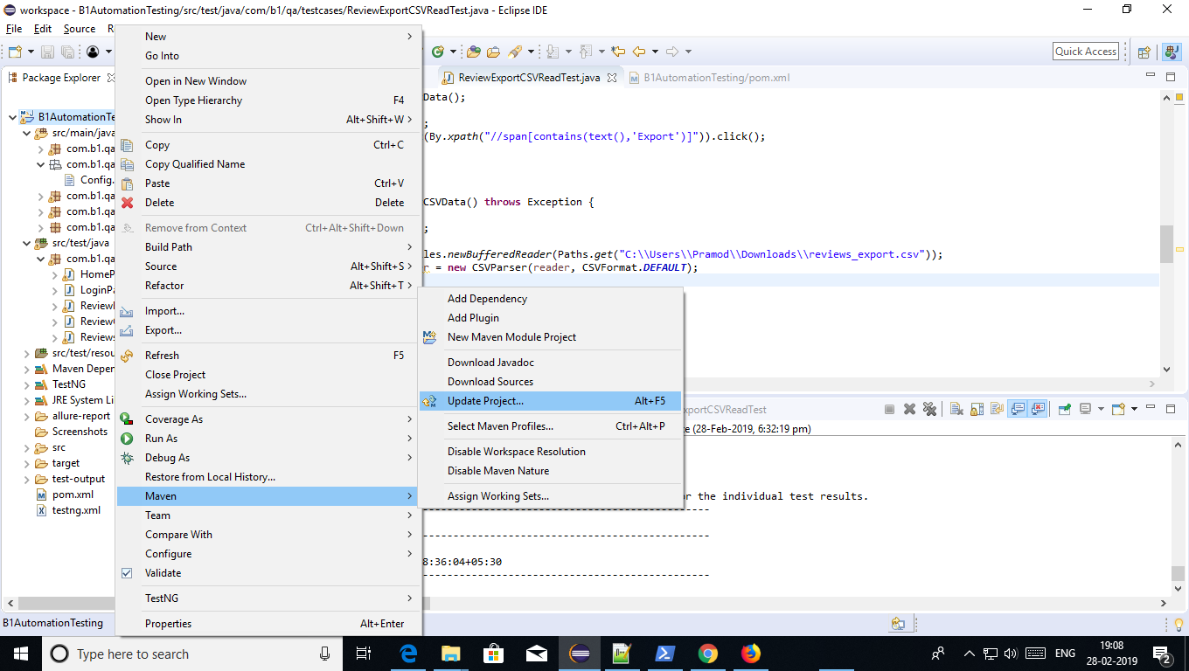

**Step 2: Click on for Update project**

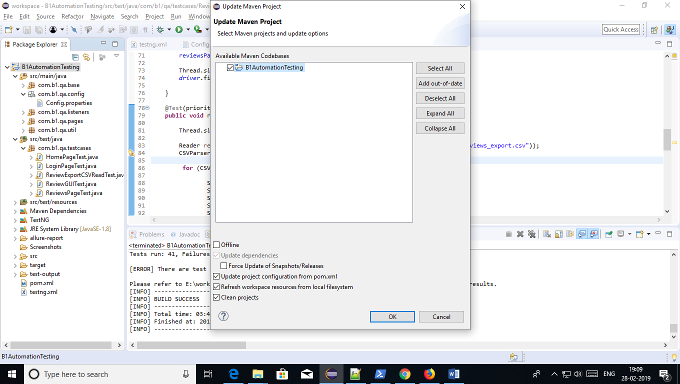

**Step 3: Clean the Project**

**Right click project > Run As > Maven Clean**

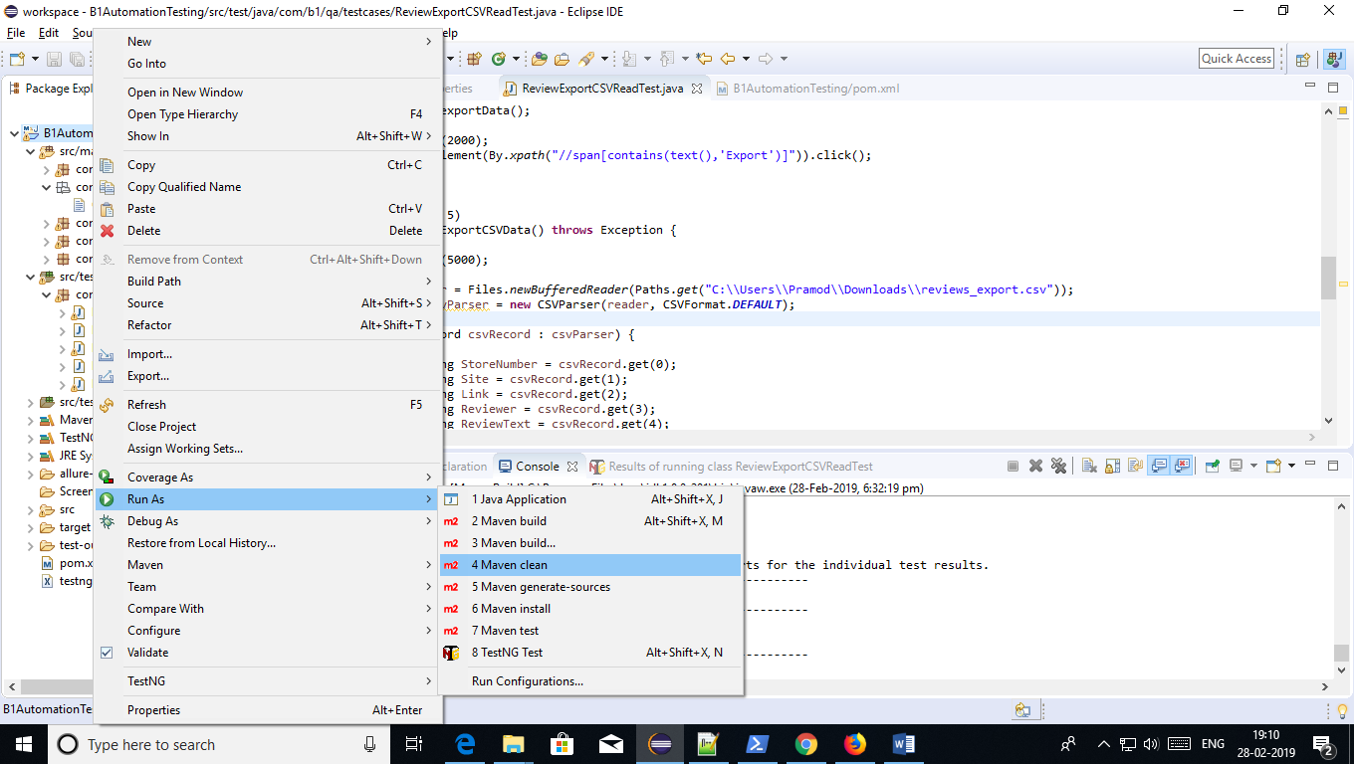

**Step 4: Build the Project**

**Right Click project > Run As > Maven Build > B1AutomationTesting : clean test**

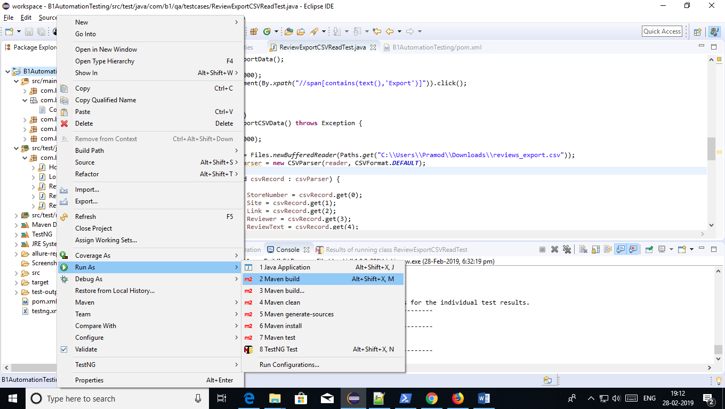

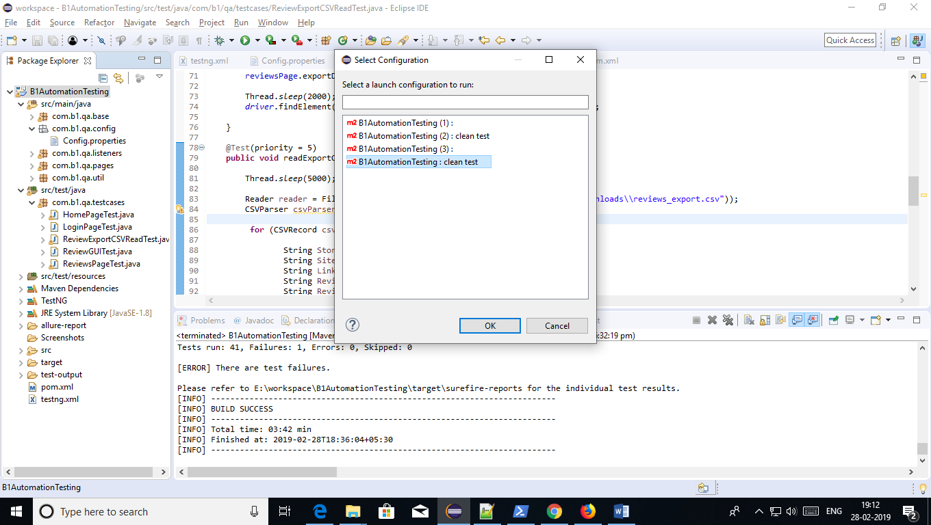

**Step 5 : Refresh the project**

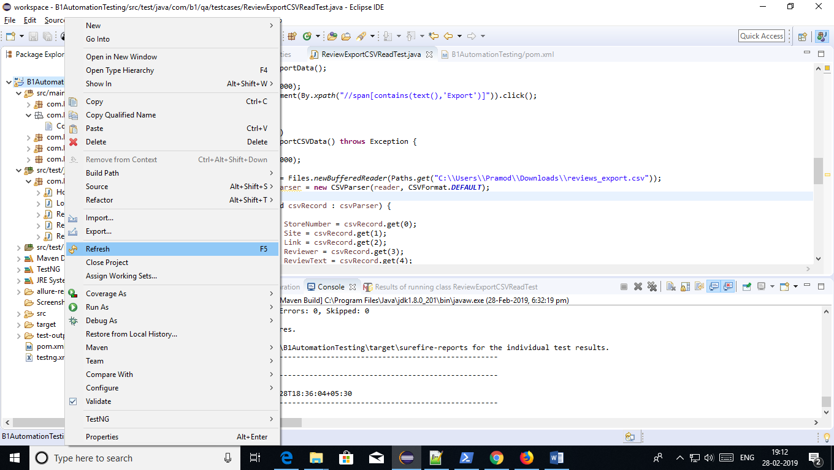

**Step 6 : Open Powershell**

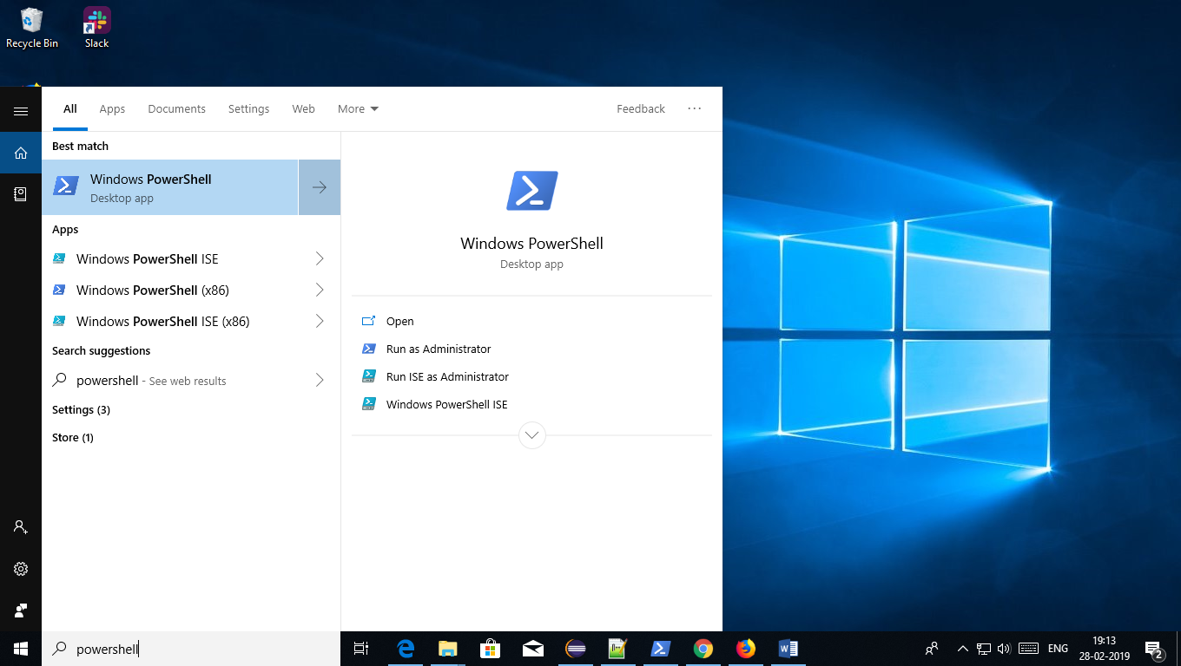

**Step 7: Enter following command in powershell to run Allure Report service:-**

* **When Powertshell gets open, Default it will display following command -**

**PS C:\Users\Pramod>**

* **Enter this command cd\ next to above line and hit enter, like this –**

**PS C:\Users\Pramod> cd\**

**It will show - PS C:\>**

* **Now enter project path next to above line, like this –**
* **PS C:\> cd E:\workspace\B1AutomationTesting\**
* **Hit Enter**
* **Then it will show PS E:\workspace\B1AutomationTesting>**
* **Here enter following command**
* **allure serve E:\workspace\B1AutomationTesting\target\allure-results**
* **Hit Enter and then Allure service getting run**
* **Automatically IE browser gets opened and Allure report showing test cases execution result.**

**Run Test Cases From Jenkins :-**

**Step 1: Go to this site -** [http://103.87.164.74](http://103.87.164.74/)

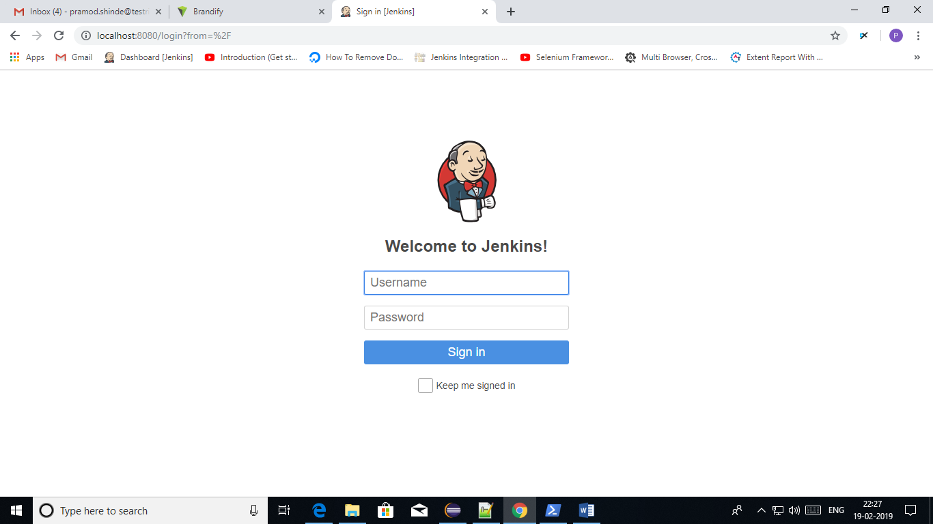

**Step 2: Login with this user credentials – pramod/tracker**

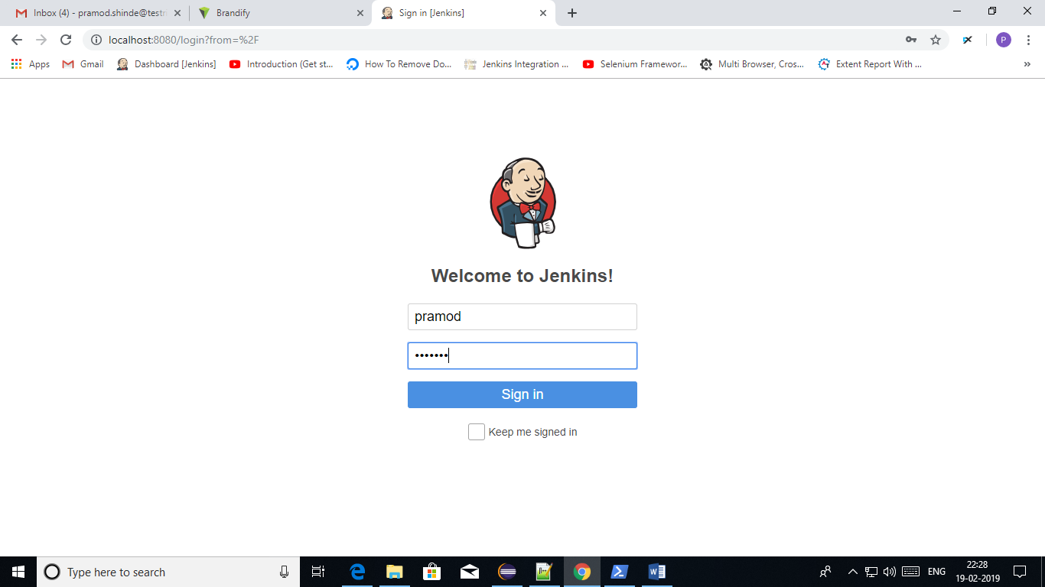

**Step 3: After Login Jenkins Dashboard page will get displayed.**

**Click on “B1AutomationTesting” project**

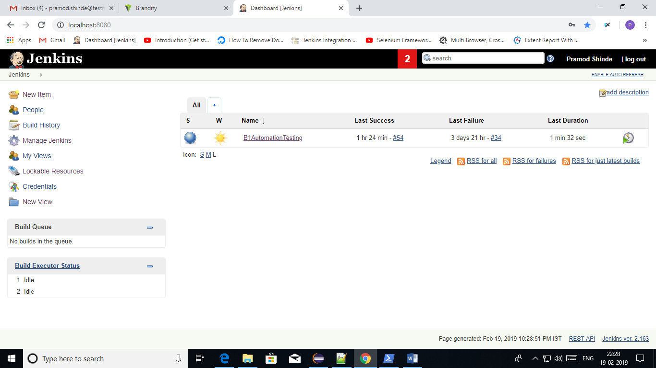

**Step 4: Click on ‘Build Now’ link which is present at Left menu of the page.**

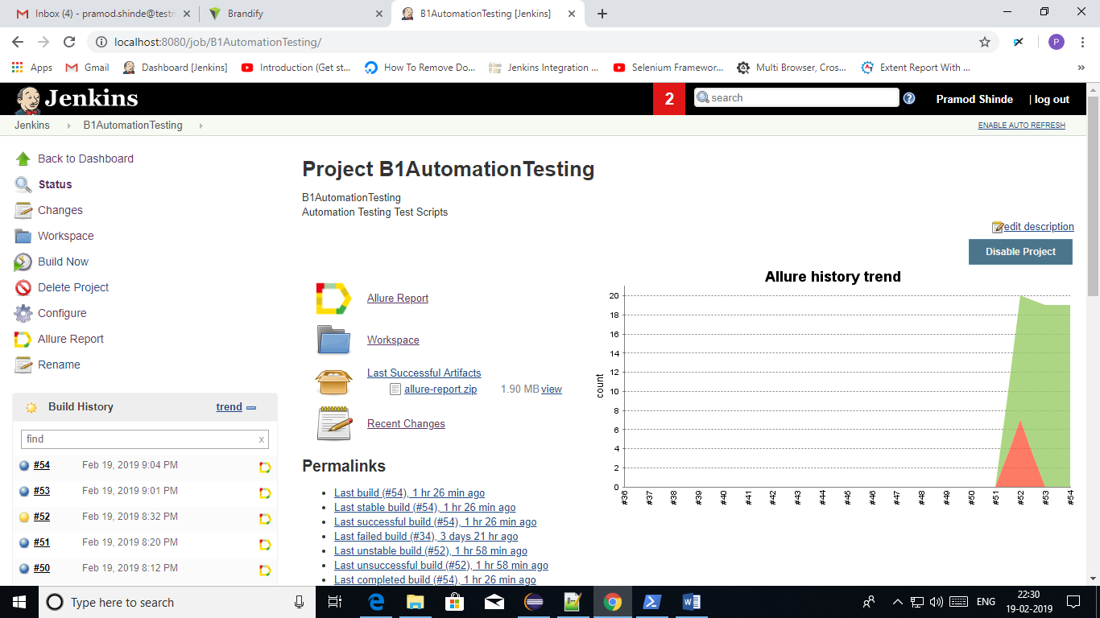

**Step 5: on clicking ‘Build Now’, Test cases execution will get start.**

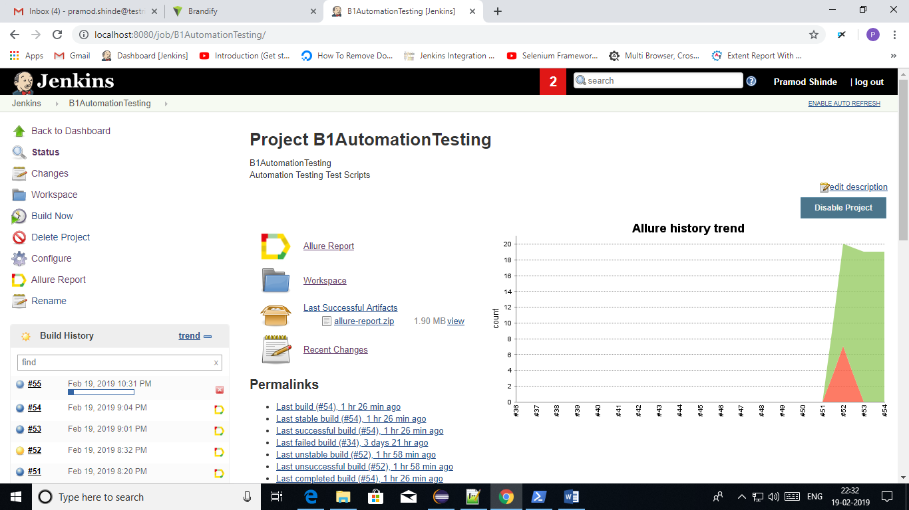

**Step 6: Click on ‘In Progress > Console Output’.**

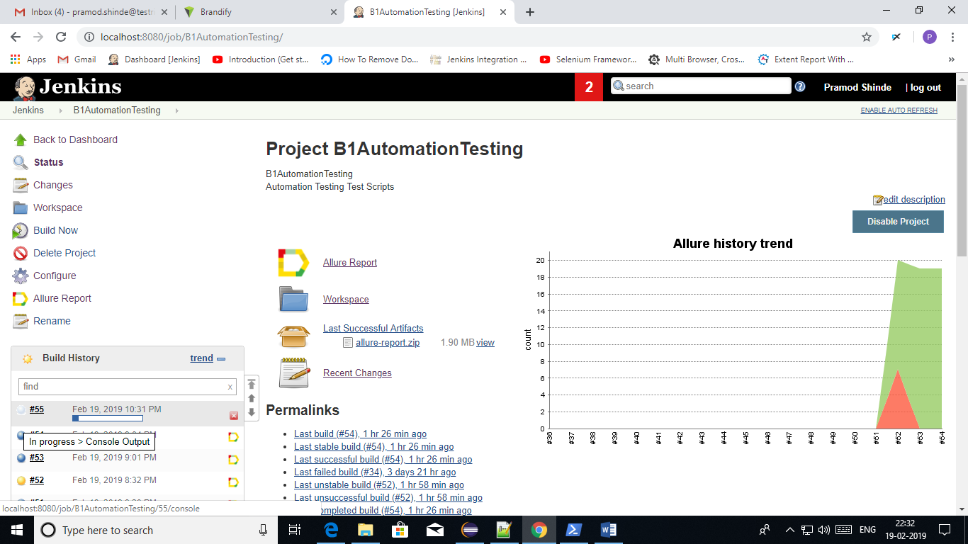

**Step 7: It will redirect to the Console Output page. It will display execution status.**

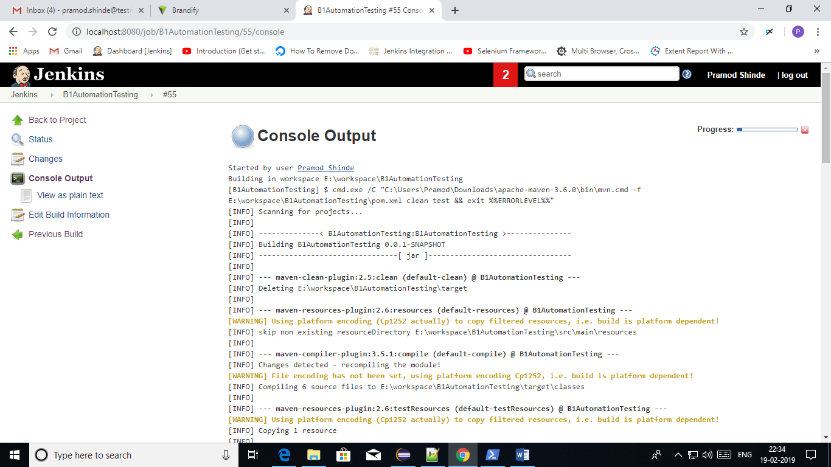

**Step 8: Once the execution is completed, click on ‘Back to Project’ link.**

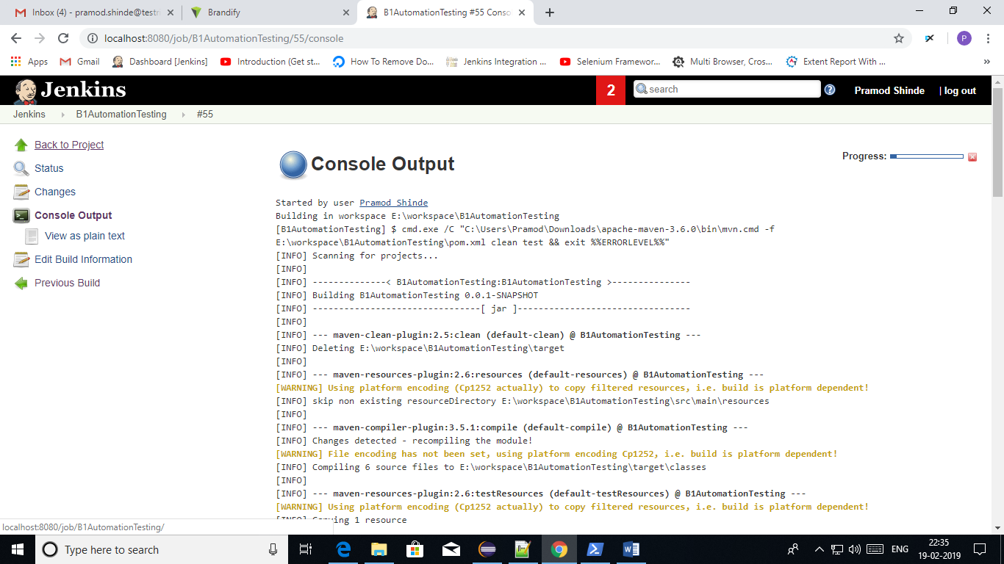

**Step 9: It will redirect to the Project details page.**

**Here You will get the Allure report. Click on ‘Allure Report’ link.**

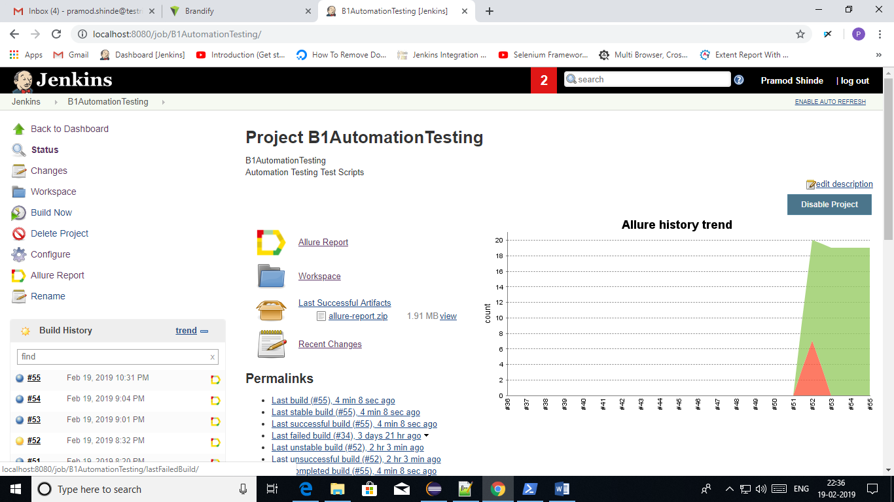

**Step 10: Allure Report will show the results in graph and pass/fail status for each test cases.**

